College of Arts and Sciences

186 University Hall
230 North Oval Mall
Columbus, OH 43210

Phone (614) 292-1667
Fax (614) 292-8666
Web artsandsciences.osu.edu

February 7, 2011

Lawrence Krissek, Professor of Earth Sciences
Faculty Chair, CCI
College of the Arts and Sciences

Dear Professor Krissek,

On February 4, 2011, the Disciplinary Advisory Panel for Curriculum of The College of Arts and Sciences, Arts and Humanities, met and reviewed the proposal for the continuation of the overlap of tagged degrees under the semester calendar. The committee unanimously voted to retain the current practice of allowing dual degrees within the arts tagged degrees with particular caveats.

In particular, the four degrees previously addressed in the Arts and Sciences bulletin/catalogue are the Bachelor of Fine Arts, the Bachelor of Art Education, the Bachelor of Music, and the Bachelor of Music Education. Lead Arts Advisor, Dennis Thompson, brought the long-standing practice to our attention and worked with Professors Richard Harned, Professor of Art and Calendar Conversion Coordinator for the Department of Art, and Tim Leasure, Associate Director and Calendar Conversion Coordinator for the School of Music. Both professors provided the minima numbers necessary for the most common combination of tagged degrees under the semester calendar below:

BFA/BAE: Minimum for the BAE-BFA will be 165 in the semester calendar. The BAE-BFA adds about a year to a student's program; students are going to need very careful advising, and it will need to be early.

BM/BME: Minimum range in credit hours under semesters required for the BM/BME is 158-168 depending on the specialization.

1. BM in Performance: Brass, Harp, Percussion, Strings, or Woodwinds combined with the BME in Instrumental: 162 units
2. BM in Performance: Brass, Harp, Percussion, Strings, or Woodwinds combined with the BME General: 160 units
3. BM in Performance: Voice combined with the BME Choral: 168 units
4. BM in Performance: Voice combined with the BME General: 164 units
5. BM in Performance: Piano combined with the BME Instrumental: 160
6. BM in Performance: Piano combined with the BME Choral: 162
7. BM in Performance: Piano combined with the BME General: 158

In sum, we ask that you carry forward a policy that has always been in place. The minima for the dual tagged degrees under semesters range from 158-168 depending on degree combination. We ask that this information be written into the ASC advising rules and distributed widely across the advisors in ASC.

Thank you for your consideration of this proposal,
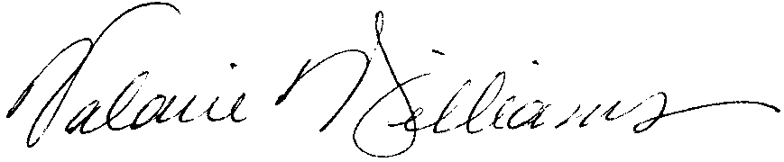
Valarie Williams, Professor of Dance
Associate Dean, College of Arts and Sciences, Arts and Humanities
Director, OSU Urban Arts Space

Cc: Dennis Thompson, ASC, Arts Advisor
Mary Ellen Jenkins, ASC, Executive Assistant Dean
Richard Harned, Professor of Art and Calendar Conversion Coordinator
Tim Leasure, Associate Director of Music and Calendar Conversion Coordinator
Mark Shanda, Dean of the Division of Arts and Humanities, College of Arts and Sciences and Professor of Theatre

